**SQL ASSIGNMENTS**

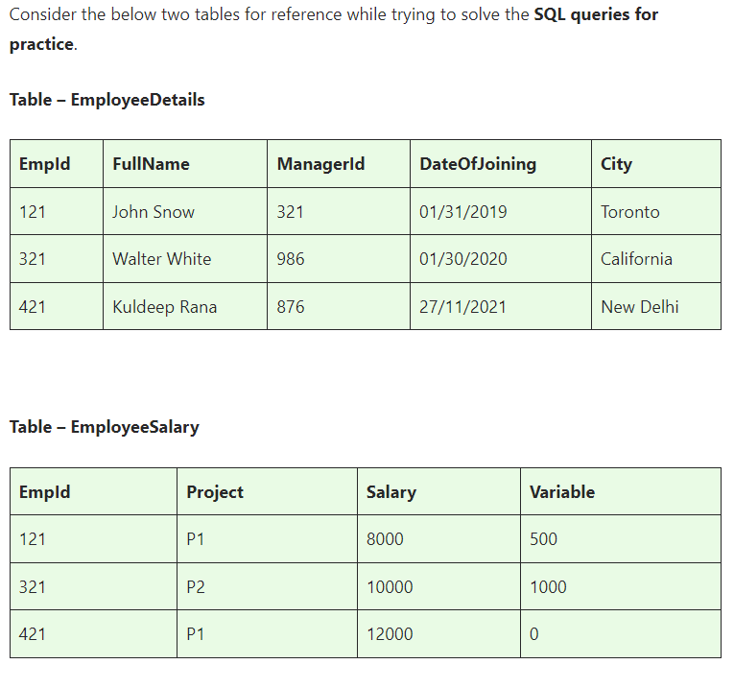

**Basics and Intermediate ASSINGMENT**

**ASSINGMENT nos - 1**

**Q1)SQL Query to fetch records that are present in one table but not in another table.**

**Q2)SQL query to fetch all the employees who are not working on any project.**

**Q3)SQL query to fetch all the Employees from EmployeeDetails who joined in the Year 2020.**

**Q4)Fetch all employees from EmployeeDetails who have a salary record in EmployeeSalary.**

**Q5)Write an SQL query to fetch a project-wise count of employees.**

**Q6)Fetch employee names and salaries even if the salary value is not present for the employee.**

**Q7)Write an SQL query to fetch all the Employees who are also managers.**

**Q8)Write an SQL query to fetch duplicate records from EmployeeDetails.**

**Q9)Write an SQL query to fetch only odd rows from the table.**

**Q10)Write a query to find the 3rd highest salary from a table without top or limit keyword.**

**ASSINGMENT nos - 2**

**Ques.1. Write an SQL query to fetch the EmpId and FullName of all the employees working under the Manager with id – ‘986’.**

**Ques.2. Write an SQL query to fetch the different projects available from the EmployeeSalary table.**

**Ques.3. Write an SQL query to fetch the count of employees working in project ‘P1’.**

**Ques.4. Write an SQL query to find the maximum, minimum, and average salary of the employees.**

**Ques.5. Write an SQL query to find the employee id whose salary lies in the range of 9000 and 15000.**

**Ques.6. Write an SQL query to fetch those employees who live in Toronto and work under the manager with ManagerId – 321.**

**Ques.7. Write an SQL query to** f**etch all the employees who either live in California or work under a manager with ManagerId – 321.**

**Ques.8. Write an SQL query to fetch all those employees who work on Projects other than P1.**

**Ques.9. Write an SQL query to display the total salary of each employee adding the Salary with Variable value.**

**Ques.10. Write an SQL query to fetch the employees whose name begins with any two characters, followed by a text “hn” and ends with any sequence of characters.**

**ASSINGMENT nos - 3**

**Ques.1 Write an SQL query to fetch all the EmpIds which are present in either of the tables – ‘EmployeeDetails’ and ‘EmployeeSalary’.**

**Ques.2 Write an SQL query to fetch common records between two tables.**

**Ques.3. Write an SQL query to fetch records that are present in one table but not in another table.**

**Ques.4. Write an SQL query to fetch the EmpIds that are present in both the tables –  ‘EmployeeDetails’ and ‘EmployeeSalary.**

**Ques.5. Write an SQL query to fetch the EmpIds that are present in EmployeeDetails but not in EmployeeSalary.**

**Ques.6. Write an SQL query to fetch the employee’s full names and replace the space**

**Ques.7. Write an SQL query to fetch the position of a given character(s) in a field.**

**Ques.8. Write an SQL query to display both the EmpId and ManagerId together.**

**Ques.9. Write a query to fetch only the first name(string before space) from the FullName column of the EmployeeDetails table.**

**Ques.10. Write an SQL query to uppercase the name of the employee and lowercase the city values.**

**ASSINGMENT nos - 4**

**Ques.1. Write an SQL query to find the count of the total occurrences of a particular character – ‘n’ in the FullName field.**

**Ques.2. Write an SQL query to update the employee names by removing leading and trailing spaces.**

**Ques.3. Fetch all the employees who are not working on any project.**

**Ques.4. Write an SQL query to fetch employee names having a salary greater than or equal to 5000 and less than or equal to 10000.**

**Ques.5. Write an SQL query to find the current date-time.**

**Ques.6. Write an SQL query to fetch all the Employee** details from the **EmployeeDetails table who joined in the Year 2020.**

**Ques.7. Write an SQL query to fetch all employee records from the EmployeeDetails table who have a salary record in the EmployeeSalary table.**

**Ques.8. Write an SQL query to fetch the project-wise count of employees sorted by project’s count in descending order.**

**Ques.9. Write a query to fetch employee names and salary records. Display the employee details even if the salary record is not present for the employee.**

**Ques.10. Write an SQL query to join 3 tables.**

**Advanced ASSINGMENT**

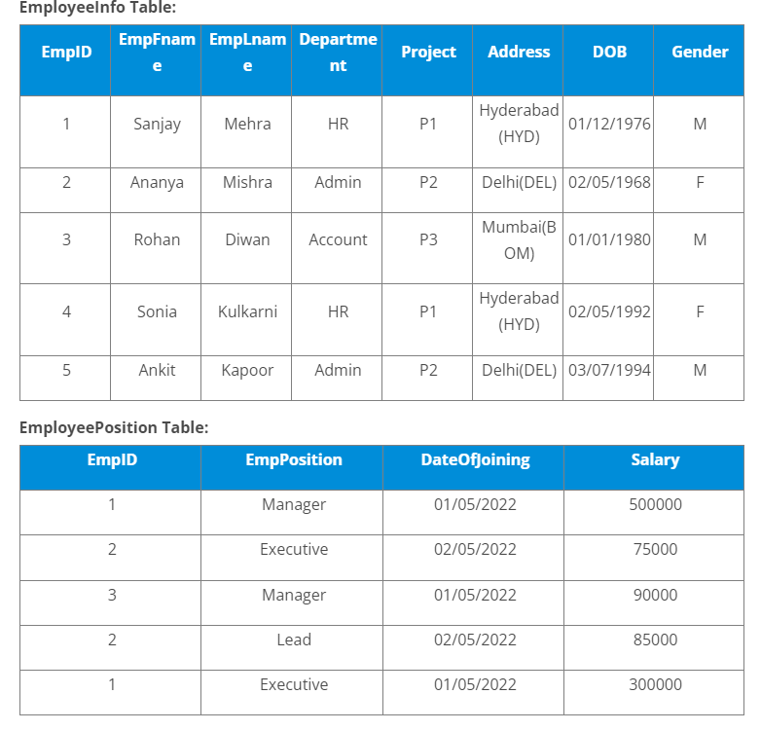

**Q1)Write a query to fetch the EmpFname from the EmployeeInfo table in the upper case and use the ALIAS name as EmpName.**

**Q2)Write a query to fetch the number of employees working in the department ‘HR’.**

**Q3)Write a query to get the current date.**

**Q4)Write a query to retrieve the first four characters of EmpLname from the EmployeeInfo table.**

**Q5)Write a query to fetch only the place name(string before brackets) from the Address column of EmployeeInfo table.**

**Q6)Write a query to create a new table that consists of data and structure copied from the other table.**

**Q7)Write q query to find all the employees whose salary is between 50000 to 100000.**

**Q8)Write a query to find the names of employees that begin with ‘S’**

**Q9)Write a query to fetch top N records.**

**Q10)Write a query to retrieve the EmpFname and EmpLname in a single column as “FullName”. The first name and the last name must be separated with space.**

### ****Q11. Write a query find number of employees whose DOB is between 02/05/1970 to 31/12/1975 and are grouped according to gender****

### ****Q12. Write a query to fetch all the records from the EmployeeInfo table ordered by EmpLname in descending order and Department in the ascending order.****

### ****Q13. Write a query to fetch details of employees whose EmpLname ends with an alphabet ‘A’ and contains five alphabets.****

### ****Q14. Write a query to fetch details of all employees excluding the employees with first names, “Sanjay” and “Sonia” from the EmployeeInfo table.****

### ****Q15. Write a query to fetch details of employees with the address as “DELHI(DEL)”.****

### ****Q16. Write a query to fetch all employees who also hold the managerial position.****

### ****Q17.**** Write a query to fetch the department-wise count of employees sorted by department’s count in ascending order.

### ****Q18. Write a query to calculate the even and odd records from a table.****

### ****Q19.**** Write a SQL query to retrieve employee details from EmployeeInfo table who have a date of joining in the EmployeePosition table.

### ****Q20. Write a query to retrieve two minimum and maximum salaries from the EmployeePosition table.****

### ****Q21.**** Write a query to find the Nth highest salary from the table without using TOP/limit keyword.

### ****Q22. Write a query to retrieve duplicate records from a table.****

### ****Q23. Write a query to retrieve the list of employees working in the same department.****

### ****Q24. Write a query to retrieve the last 3 records from the EmployeeInfo table.****

### ****Q25. Write a query to find the third-highest salary from the EmpPosition table.****

### ****Q26. Write a query to display the first and the last record from the EmployeeInfo table.****

### ****Q27. Write a query to add email validation to your database****

### ****Q28. Write a query to retrieve Departments who have less than 2 employees working in it.****

### ****Q29. Write a query to retrieve EmpPostion along with total salaries paid for each of them****

### ****Q30. Write a query to fetch 50% records from the EmployeeInfo table.****

